Lesson 2
Improper Integrals

Introduction

So far in our study of integration, we have considered 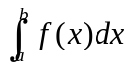 where f is a bounded function on the bounded interval [a, b]. It was noted that the interval [a, b] was finite.

We now want to see what happens when either f or the interval [a, b] becomes unbounded. In either case, we have what is called an improper integral (the integrals we have seen so far are called proper integrals). As you will see, an improper integral is not defined directly in terms of partitions and sums, but is instead defined as a limit of proper integrals.
Definition:
The integral is an improper integral if:
(i) or 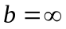or both (i.e. one or both of the limits of integration is infinite)
(ii) in which the integrand becomes infinite somewhere in the range of integration.

The following are examples of improper integrals:

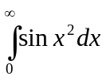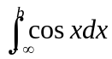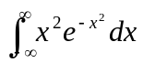

1.1 Integrals over Unbounded Intervals (Improper Integrals with Infinite Limits of Integration)

A function f which is continuous on an unbounded interval [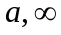)

A) One Infinite Limit

1.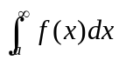= 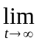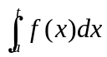

2. 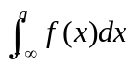= 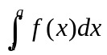

B) Both Infinite Limit

1. 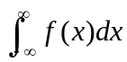 = 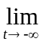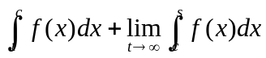

Convergent and Divergent

If the limit in an improper integral doesn’t exist (or is infinite), the integral diverges. If the limit is a finite number L, then the integral is said to converge to L.

Examples

1. 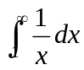 5. 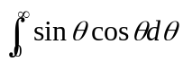

2. 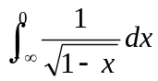 6. 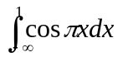

3. 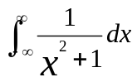 7. 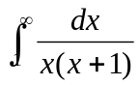
4. 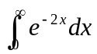

1.2. Integrals of Unbounded Functions

A) Integrands which are infinite at an endpoint

If f is continuous on the half-open interval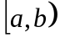 but the limit of f(x) as 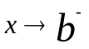 is infinite, we define;

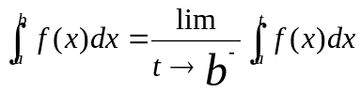

If f is continuous on the half-open interval 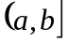 but the limit of f(x) as 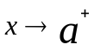 is infinite, then we define;

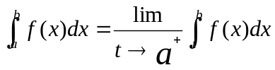

B) Integrands that are infinite at an interior point

If f is continuous at every point of 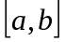 except for the one point c is (a, b) and one or both are sided limit of f at c are infinite, then we define;

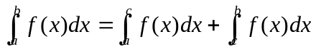

Examples:

1. 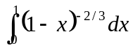 = 3 4. 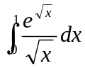

2. 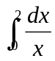 diverges 5. 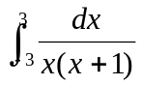

3. 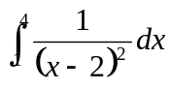 diverges 6. 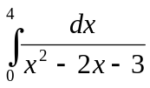

Supplementary Problems in Improper Integrals

Example 1

Given: 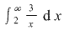
Solution: First take the 3 outside the integral.
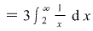
Integrate 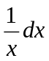. From the integration formula:
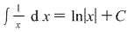
So:

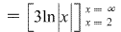

Now from the Fundamental Theorem of Calculus Plug in the upper limit (infinity) and the lower limit 2: F(B)-F(A)

Since the improper integral goes to positive infinity, it is DIVERGENT.

Example 2
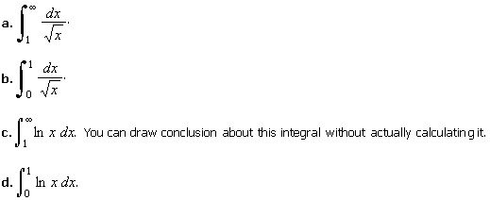
Solution:
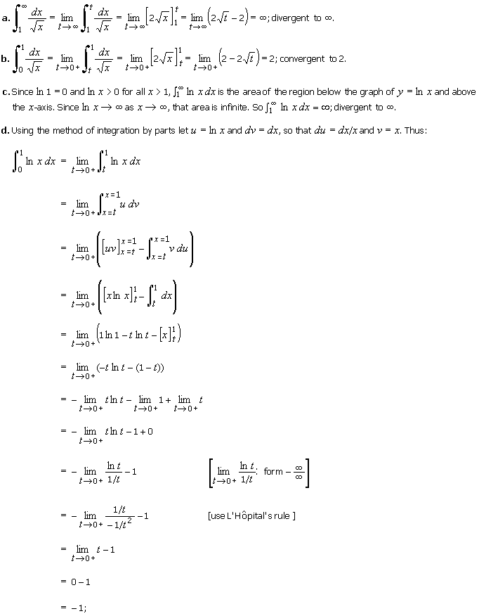
Hence, -1 is convergent
Example 3

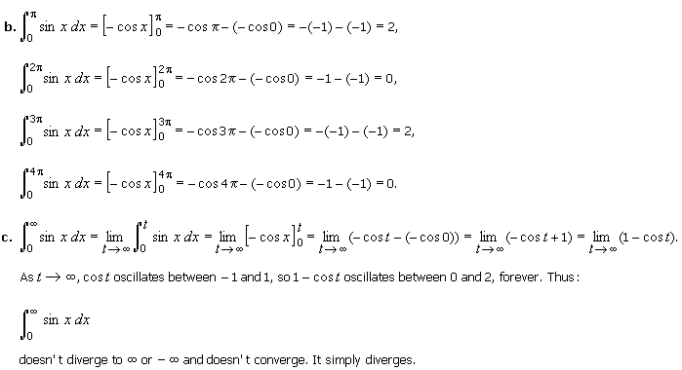

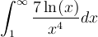
Example 4

Solution: INTEGRATING BY PARTS

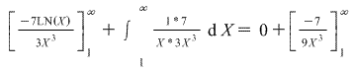
= 7/9

Homework # 1

Evaluate the following improper integrals.
1. 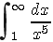 2. 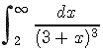
3. 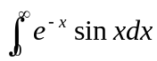 4. 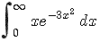
5. 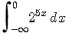 6. 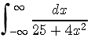
7. 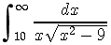 8. 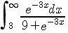

9. 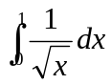 10. 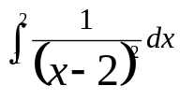

11. 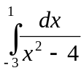 12. 